Faculty Submitting: Allison Kelly
Specify here whether “Pre” or “End” of Unit and the Unit #: End Unit 9
Notes from the author:
- I don’t know that we should use all of these in one assignment but I figured the more we have in the bank we can switch them out or group them if they become compromised.
- **Difficult problem; maybe should included a link to a “guided solution” or “video solution”
- Should we link to the portion in the textbook for each of these problems? Like a hyperlink that says “Learn More About This”
LO: Sketch and interpret phase diagrams – normal boiling point, critical point, triple point
Unit 9_ Question 1  ** | Canvas Question Type: Formula
Question Text: A piece of ice sitting on a hot sidewalk on a hot summer day will eventually melt and then evaporate. If the ice weighs [mass] g, how much energy would be required (in kJ) to melt the ice and vaporize the ice cube?
T°_{M} | 0.00 °C
T°_{B} | 100.0 °C
Specific heat of liquid water (c_{liquid}) | 4.184 J/g °C
Enthalpy of Fusion (ΔH_{fus}) | 6.02 kJ/mol
Enthalpy of Vaporization (ΔH_{vap}) | 40.7 kJ/mol

Formula: (mass/18.015*6.02)+(mass/18.015*40.7)+(mass*4.184*100/1000)
Mass: 30-50 g, 1 decimal place
Read More | https://openstax.org/books/chemistry-2e/pages/10-3-phase-transitions#CNX_Chem_10_03_HeatCurve
Unit 9_ Question 2 | Canvas Question Type: Formula
Question Text: The enthalpy of fusion (ΔH_{fus}) for aluminum is 8.66 kJ/mol. How much energy (in kJ) is released when [mass] kg of liquid aluminum solidifies?
Note: Although heat "released" is symbolically negative, please insert a positive value below for the heat.
Formula:(mass*1000/26.981*8.66)
Mass: 0.5-3.5, 2 decimal places
Read More | https://openstax.org/books/chemistry-2e/pages/10-3-phase-transitions#CNX_Chem_10_03_Evap
Unit 9_ Question 3 | Canvas Question Type: Formula
 | A common technique for forming metal electrodes on electronic devices is evaporation in a vacuum. In this technique the metal is melted in a heat resistant boat and then vaporized, eventually landing onto the desired surface. How much energy in Joules is required to vaporize [mass] g of liquid gold? The enthalpy of vaporization (ΔH_{vap}) for gold is 310.9 kJ/mol.
Formula: mass/196.966*310.9*1000
Mass: 2-6, 2 decimal places
Read More | https://openstax.org/books/chemistry-2e/pages/10-3-phase-transitions#CNX_Chem_10_03_Evap
Unit 9_ Question 4 | Canvas Question Type: Numeric Answer  Question GROUP
4a | The following graph indicates the vapor pressure of a liquid as a function of temperature.  What is the normal boiling point of this liquid? (Do NOT include units in the answer box)  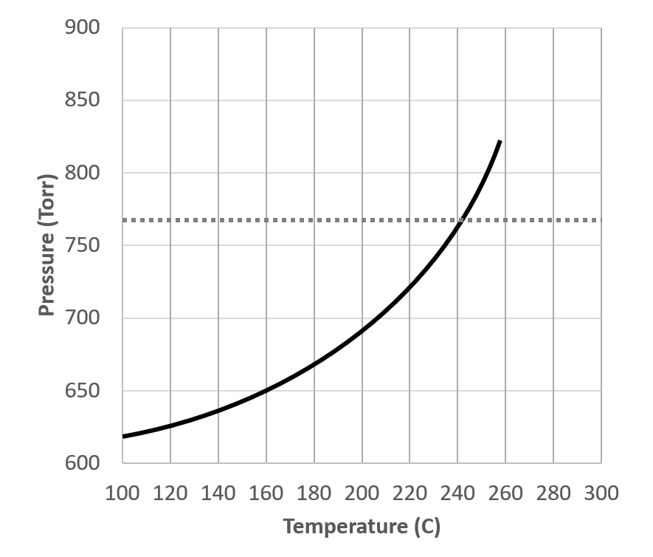  ALT TEXT: The figure represents a graph with an upward curving line. The x axis is Temperature in degrees C from 100 to 300. The y axis is Pressure in Torr from 600 to 900. There is a horizontal dashed line at approximately 760 torr, which appears to intersect with the curving line at 240 torr.
 | Answer: 239-245
4b | The following graph indicates the vapor pressure of a liquid as a function of temperature.  What is the normal boiling point of this liquid? (Do NOT include units in the answer box)  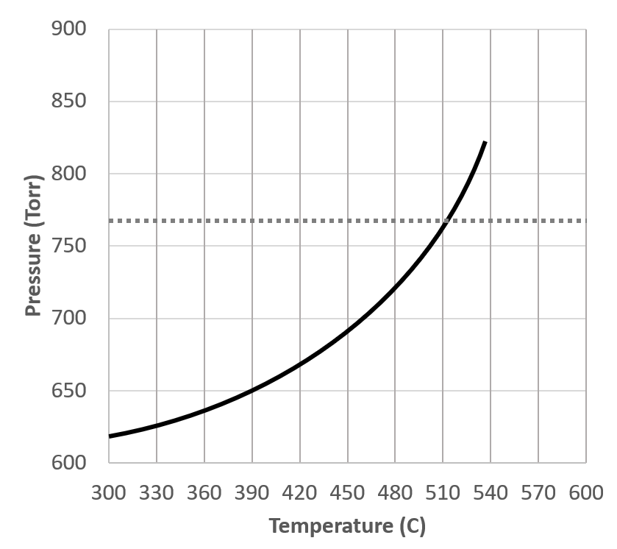  ALT TEXT: The figure represents a graph with an upward curving line. The x axis is Temperature in degrees C from 300 to 600. The y axis is Pressure in Torr from 600 to 900. There is a horizontal dashed line at approximately 760 torr, which appears to intersect with the curving line at 510 torr.
 | Answer: 509-515
Read More | https://openstax.org/books/chemistry-2e/pages/10-3-phase-transitions#CNX_Chem_10_03_VapPress2
Unit 9_ Question 5 | Canvas Question Type: Numeric Answer  Question GROUP
5a | The following graph indicates the vapor pressure of a liquid as a function of temperature.  What is the boiling point of this liquid on the top of a mountain at roughly 1600 feet of elevation where the atmospheric pressure is 650 torr? (Do NOT include units in the answer box)  ALT TEXT: The figure represents a graph with an upward curving line. The x axis is Temperature in degrees C from 100 to 300. The y axis is Pressure in Torr from 600 to 900. There is a horizontal dashed line at approximately 760 torr, which appears to intersect with the curving line at 240 torr.
Answer : 160
Margin: +/- 1
5b | The following graph indicates the vapor pressure of a liquid as a function of temperature.  What is the boiling point of this liquid on the top of a mountain at roughly 1600 feet of elevation where the atmospheric pressure is 650 torr? (Do NOT include units in the answer box)  ALT TEXT: The figure represents a graph with an upward curving line. The x axis is Temperature in degrees C from 300 to 600. The y axis is Pressure in Torr from 600 to 900. There is a horizontal dashed line at approximately 760 torr, which appears to intersect with the curving line at 510 torr.
Answer: 390
Margin +/- 1
Read More | https://openstax.org/books/chemistry-2e/pages/10-3-phase-transitions#CNX_Chem_10_03_VapPress2
Unit 9_ Question 6 | Canvas Question Type: Multiple Drop Downs
Label the sections on the following heating curve
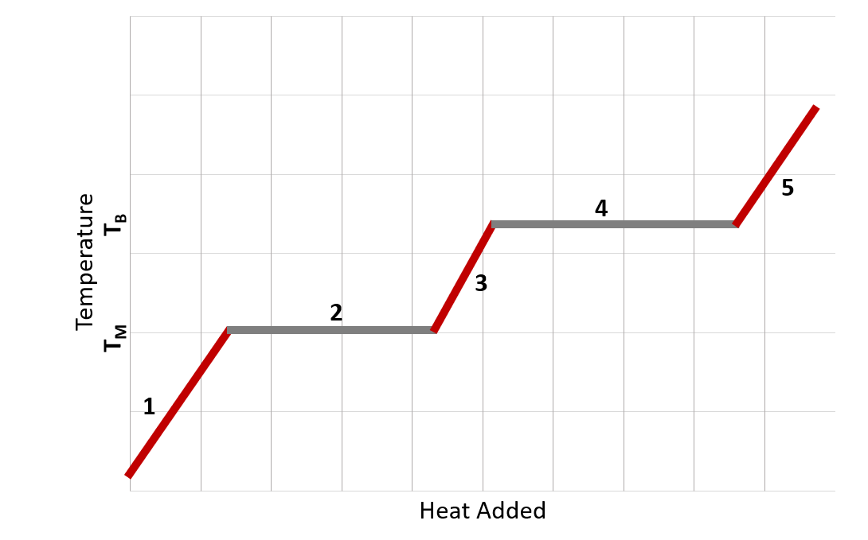
ALT TEXT: The figure shows a general heating curve. The y axis is labelled temperature, with Tm and Tb indicated. The x axis is labelled heat added. Each segment is labelled. The segment labelled 1 is increasing with a positive slope. The second segment is a plateau at Tm on the y axis. The third segment is increasing with a positive slope. The fourth segment is a plateau at Tb. The fifth segment is increasing with a positive slope.

- [DropOne]
- [DropTwo]
- [DropThree]
- [DropFour]
- [DropFive]
DropOne
Correct: Increasing Temperature
Wrong:
Decreasing Temperature
Melting
Freezing
Vaporization
Condensation
DropTwo
Correct: Melting
Wrong:
Decreasing Temperature
Increasing Temperature
Freezing
Vaporization
Condensation
DropThree
Correct: Increasing Temperature
Wrong:
Decreasing Temperature
Melting
Freezing
Vaporization
Condensation
DropFour
Correct: Vaporization
Wrong:
Increasing Temperature
Decreasing Temperature
Melting
Freezing
Condensation
DropFive
Correct: Increasing Temperature
Wrong:
Decreasing Temperature
Melting
Freezing
Vaporization
Condensation
Read More | https://openstax.org/books/chemistry-2e/pages/10-3-phase-transitions#CNX_Chem_10_03_HeatCurve
Unit 9_ Question 7 | Canvas Question Type: Multiple Choice  QUESTION GROUP
7a | On the following phase diagram, Point A is ________.  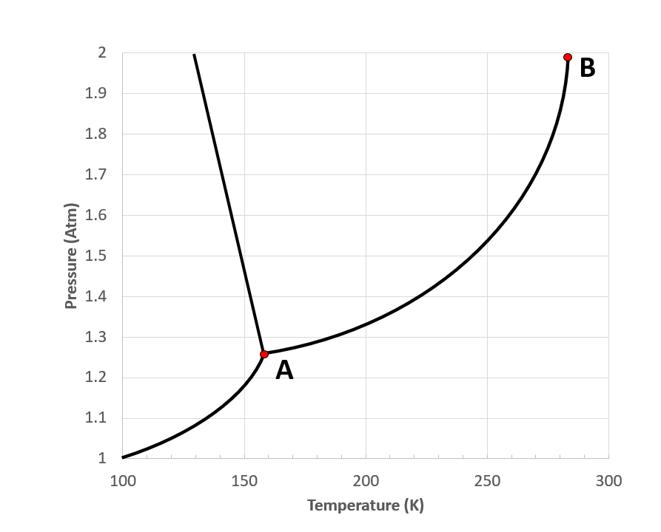  ALT TEXT: The figure shows a general Y shaped phase diagram. The y axis is pressure in atm. The x axis is temperature in K. The point where all three lines converged is labelled A. The point to the upper right end of the Y is labelled B.  Correct Answer: triple point  Wrong Answers:  critical point  normal boiling point  normal melting point
7b | On the following phase diagram, Point B is ________.  ALT TEXT: The figure shows a general Y shaped phase diagram. The y axis is pressure in atm. The x axis is temperature in K. The point where all three lines converged is labelled A. The point to the upper right end of the Y is labelled B.  Correct Answer: critical point  Wrong Answers:  triple point  normal boiling point  normal melting point
Read More | https://openstax.org/books/chemistry-2e/pages/10-4-phase-diagrams
Unit 9_ Question 8 | Canvas Question Type: Matching
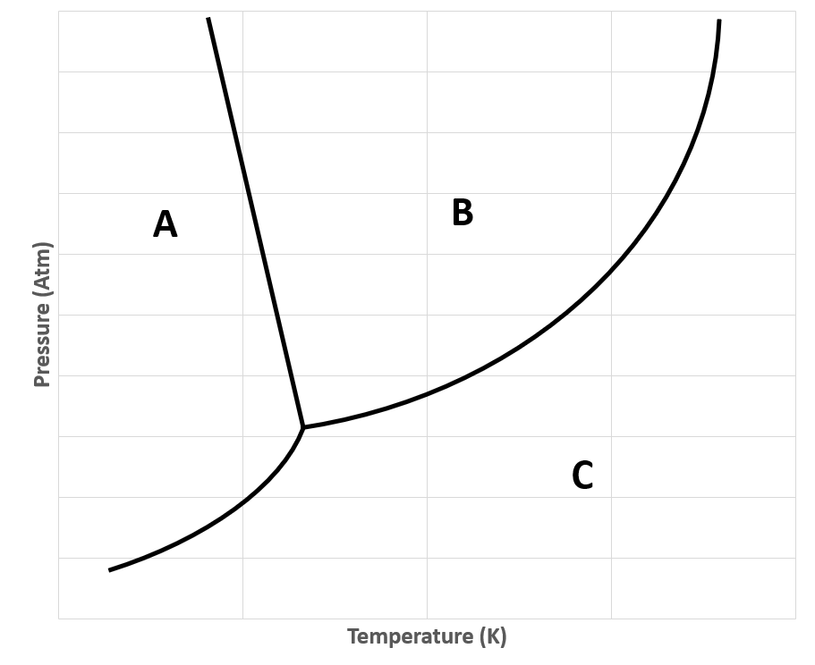
ALT TEXT: The figure represents a general Y shaped phase diagram. The x axis is labelled Temperature in kelvin. The y axis is labelled pressure in atm. The segment of the diagram at low temperatures and mid to high pressure is labelled A. The segment of the diagram at mid temperatures and high pressures is labelled B. The segment of the diagram at high temperatures and low pressures is labelled C.

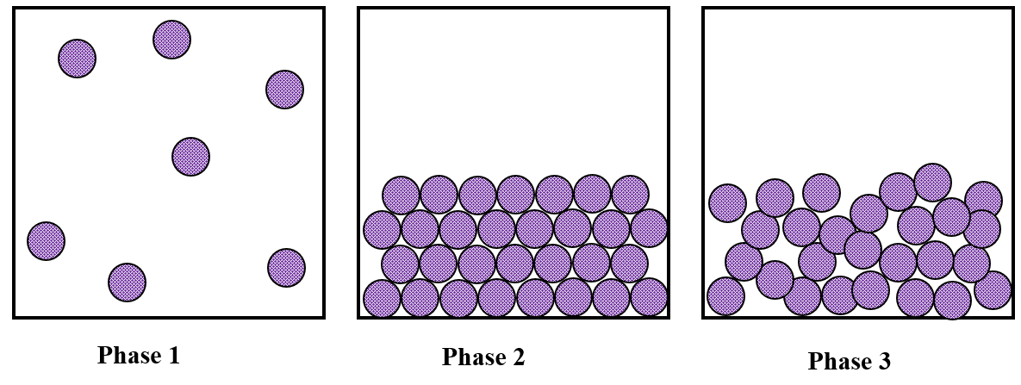
ALT TEXT: The figure shows three boxes. The left box is labelled Phase 1 and shows circles spread throughout the box randomly. The middle box is labelled Phase 2 and shows circles arranged uniformly at the bottom of the box. The right box is labelled Phase 3 and shows circles arranged overlapping each other at the bottom of the box.

Match the phases pictured with the area in the phase diagram that they represent
Phase 1 – C
Phase 2 – A
Phase 3 – B
Read More | https://openstax.org/books/chemistry-2e/pages/10-4-phase-diagrams
Unit 9_ Question 9 | Canvas Question Type: Multiple Drop Downs
Given the following phase diagram:
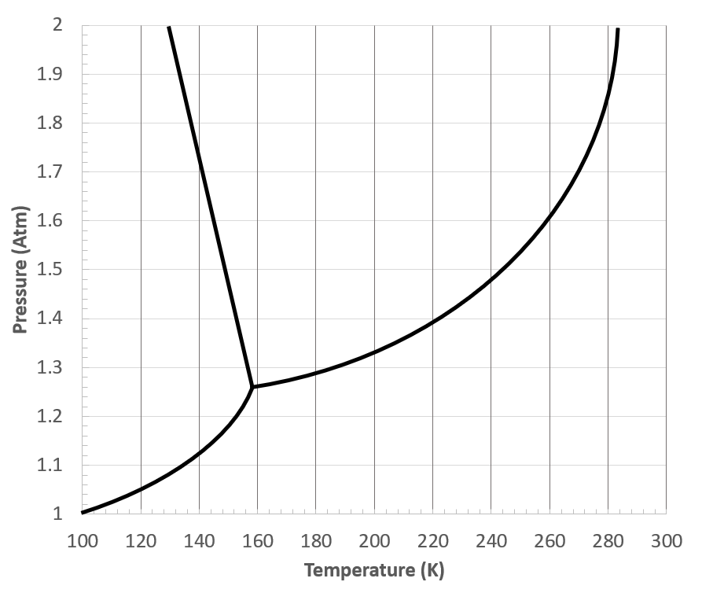
ALT TEXT: The figure shows a phase diagram with a general Y shape. The y axis is in pressure, atm from 1 to 2 in 0.1 increments. The x axis is in temperature K from 100 to 300. The point where all three lines converge seems to be between 1.2 and 1.3 atm and 140 and 160 K. The top of the left line sits between 120 and 140 K and 2 atm. The top of the right line is between 280 and 300 K at 2 atm

What phase transition occurs in each of the following cases.
Increasing temperature from 120 K to 180 K at 1.5 atm. [DropOne]
Increasing pressure from 1.4 atm to 1.9 atm at 140 K [DropTwo]
Decreasing temperature from 160 K to 120 K at 1.1 atm [DropThree]
Increasing pressure from 1.3 atm to 1.6 atm at 240 K [DropFour]
DropOne
Correct Answer: Melting
Wrong Answers:
Freezing
Vaporization
Condensation
Sublimation
Deposition
DropTwo
Correct Answer: Melting
Wrong Answers:
Freezing
Vaporization
Condensation
Sublimation
Deposition
DropThree
Correct Answer: Deposition
Wrong Answers:
Freezing
Vaporization
Condensation
Sublimation
Melting
DropFour
Correct Answer: Condensation
Wrong Answers:
Freezing
Vaporization
Melting
Sublimation
Deposition
Read More | https://openstax.org/books/chemistry-2e/pages/10-4-phase-diagrams
LO: Identify molecular/ion interactions based upon structures – hydrogen bonding, dipole-dipole and London Dispersion Forces
Unit 9_ Question 10 | Canvas Question Type: Multiple Answers
Select all of the IMFs that the following molecule experiences.
SF₆
Correct Answers:
London Dispersion Forces
Wrong Answers:
Dipole-dipole
Hydrogen Bonding
Ion-Dipole

Read More | https://openstax.org/books/chemistry-2e/pages/10-1-intermolecular-forces
Unit 9_ Question 11 | Canvas Question Type: Multiple Answers
Select all of the IMFs that the following molecule experiences.
C₈H₁₆

Correct Answers:
London Dispersion Forces
Wrong Answers:
Dipole-dipole
Hydrogen Bonding
Ion-Dipole
Read More | https://openstax.org/books/chemistry-2e/pages/10-1-intermolecular-forces
Unit 9_ Question 12 | Canvas Question Type: Multiple Answers
Select all of the IMFs that the following molecule experiences.
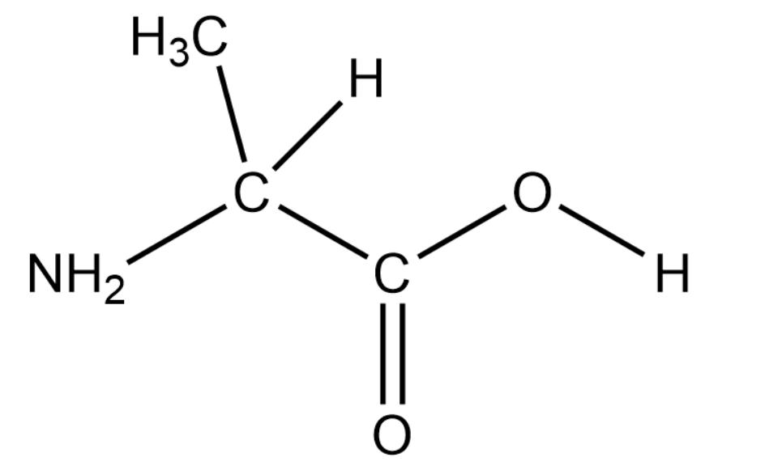
ALT TEXT: The figure illustrates a formula with the following structure: A chain of three carbon atoms, the leftmost carbon has three single bonds to H. The second carbon has a single bond to H and a single bond to a Nitrogen (which has two H atoms bonded). The third carbon has a double bond to oxygen and a single bond to an O H group.
Correct Answers:
London Dispersion Forces
Dipole-dipole
Hydrogen Bonding
Wrong Answers:
Ion-Dipole
Read More | https://openstax.org/books/chemistry-2e/pages/10-1-intermolecular-forces
Unit 9_ Question 13 | Canvas Question Type: Multiple Choice
Which of the following molecules is most likely to be a gas at room temperature?
Correct Answer: C₃H₈
Wrong Answers:
C₃H₇OH
C₅H₁₂
C₅H₁₁OH
Read More | https://openstax.org/books/chemistry-2e/pages/10-1-intermolecular-forces
Unit 9_ Question 14 | Canvas Question Type: Matching
Rank the following molecules from lowest viscosity to highest viscosity
Lowest Viscosity
- C₄H₈
- C₃H₇NH₂
- C₈H₁₇OH
Highest Viscosity
Read More | https://openstax.org/books/chemistry-2e/pages/10-1-intermolecular-forces
Unit 9_ Question 15 | Canvas Question Type: Multiple Choice
For which of the following pairings is the substance with the higher melting point listed first
- NH₃ and CH₄
- CH₄ and C₂H₄
- CH₃CH₂CH₂NH₂ and CH₃CH₂CH₂CH₃

Correct Answer: I and III
Wrong Answer:
I and II
I, II and III
II and III
I only
II only
III only
Read More | https://openstax.org/books/chemistry-2e/pages/10-1-intermolecular-forces
Unit 9_ Question 16 | Canvas Question Type: Multiple Drop Down
Identify whether the following processes involve intramolecular or intermolecular forces
Wine ferments in an barrel [DropOne]
Sugar dissolves when stirred into coffee [DropTwo]
Dropping bleach on a shirt removes the color [DropThree]
Yeast in warm water forms bubbles [DropFour]
The windshield fogs up in winter [DropFive]
DropOne
Correct Answer: intramolecular
Wrong Answer: intermolecular
DropTwo
Correct Answer: intermolecular
Wrong Answer: intramolecular
DropThree
Correct Answer: intramolecular
Wrong Answer: intermolecular
DropFour
Correct Answer: intramolecular
Wrong Answer: intermolecular
DropFive
Correct Answer: intermolecular
Wrong Answer: intramolecular
Read More | https://openstax.org/books/chemistry-2e/pages/10-1-intermolecular-forces
Unit 9_ Question 17 | Canvas Question Type: Multiple Choice
Consider the following statements:
“Molecule A has a higher surface tension than Molecule B.”
“Molecule C has a higher vapor pressure than Molecule B.”
Which molecule will have the lowest melting point?
Correct Answer: Molecule C
Wrong Answers:
Molecule A
Molecule B
Not enough information to tell

Read More | https://openstax.org/books/chemistry-2e/pages/10-1-intermolecular-forces
LO: Prepare solutions and calculate solution concentration using molarity, molality, weight percent, mole fraction
Unit 9_ Question 18 | Canvas Question Type: Formula Answer
 | What is the molality of a solution when [mass] g of KMnO₄ is dissolved in [vol] mL of water (assume the density of water is 0.999 g/mL?
Answer: (mass/158.034)/(vol*0.999/1000)
mass: 60-80, one decimal place
vol: 500-900, zero decimal places
Read More
Unit 9_ Question 19 | Canvas Question Type: Formula Answer
 | What is the mole fraction of solute when [moleth] mols of ethanol is added to [molsw] mols of water?
Answer: moleth/(moleth+molsw)
moleth: 0.5-2.5, two decimal place
molesw: 3-10, one decimal place
Read More | https://openstax.org/books/chemistry-2e/pages/11-4-colligative-properties
Unit 9_ Question 20  ** | Canvas Question Type: Formula Answer
 | What is the molality of an aqueous solution of glucose, C₆H₁₂O_{6,} that is [molar] M? Assume the density of the solution is [density] g/mL
 | molar/(((density*1000)-(Molar*180.156))/1000)
Read More | https://openstax.org/books/chemistry-2e/pages/11-4-colligative-properties
Unit 9_ Question 21  ** | Canvas Question Type: Formula Answer
 | A given cup of coffee contains [conc] g/mL of caffeine (C₈H₁₀N₄O₂). What is the mole fraction of caffeine in a cup of coffee? (The density of water is 0.983g/mL at 60 °C)
(conc/194.19)/(conc/194.19+1.00*0.983/18.015)
Conc: 0.338-0.422; 3 decimal places
Read More | https://openstax.org/books/chemistry-2e/pages/11-4-colligative-properties
Unit 9_ Question 22 | Canvas Question Type: Formula Answer
 | In lab, your spectrophotometer has a maximum detection limit of [A] M. The solution you want to measure has a concentration of [B] M, so you measure out [vol] mL and dilute it to [volb] mL. What is the final concentration of your solution?
Answer: B*vol/volb
A: 1.0-1.5, one decimal
B: 2-4, one decimal
vol: 25-50, one decimal
volb: 150-500, one decimal
Read More | https://openstax.org/books/chemistry-2e/pages/3-3-molarity
Unit 9_ Question 23 | Canvas Question Type: Formula Answer
 | What is the mass percent of sugar in a beverage if [massj] g of the drink contains [mass] g of sugar?
mass/(massj)*100
massj: 450-650, one decimal
mass: 20-40, one decimal
Read More | https://openstax.org/books/chemistry-2e/pages/3-4-other-units-for-solution-concentrations

